Documentation

of

Project 66643

Created by :

* Md. Muhibbur Rahman [577952-Leader]
* Md. Alfi Mia [577961]
* Ajijoul Hakim [577948]
* Sadikul [577982]
* Mohiuddin Naeem [577971]
* Overview :

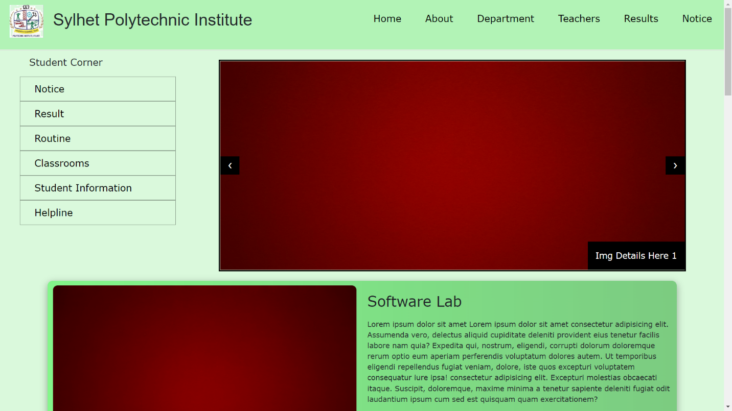

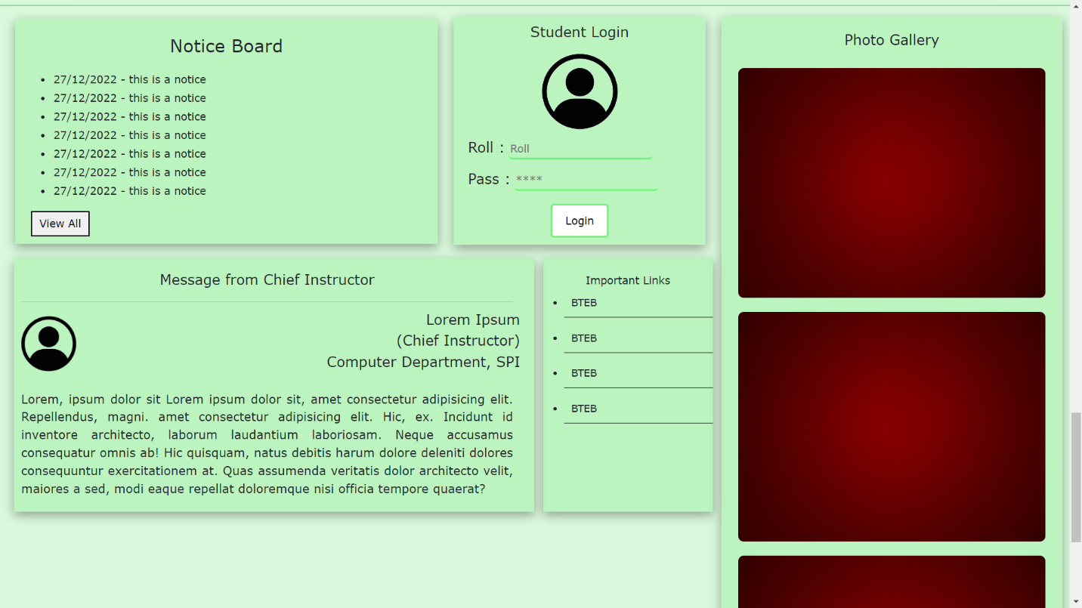

Main Page (index.html)